**1.Pool**:- pool is set of same items. It gives the reusability of same items.

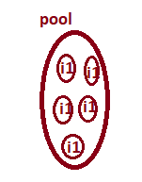

Example:- Object pool, connection pool, chair pool … etc.

**2. Connection Pool:-** The connection pool is factory. That contains set of readily avialble JDBC connection objects. All connection objects in pool represents the connectivity with the same DB s/w.

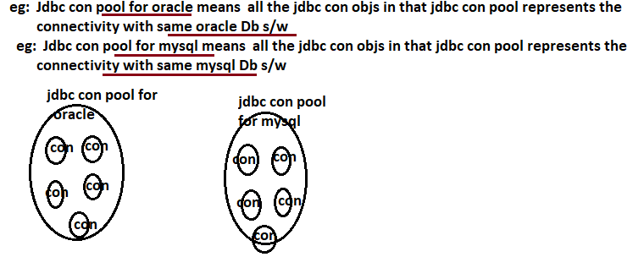

Advantages:-

1. Gives the reusability for JDBC connection objects.
2. With minimum Objects, Max apps/clients talk to same DB software.
3. Creating, deleting and managing Connection objects in JDBC connection pool will be taken care by jdbc connection pool.

**3. Types of connection Pool:-**

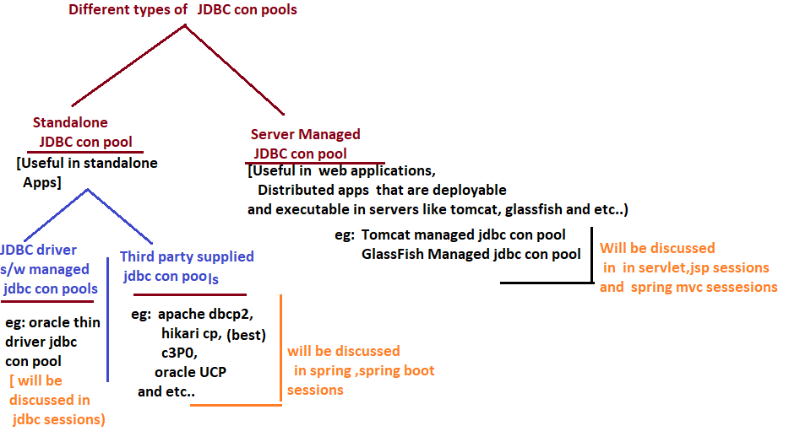

**4. Process to Implement connection pooling:-**

**4.1. Create Data source object:-** The data source object represents the JDBC connection pool (i.e) we can access the connection object from pool using DataSource object.

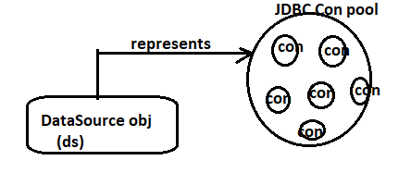

DataSource is an interface present in javax.sql package.

Oracle provided the implementation class to this interface. The implementation class name is “OracleConnectionPoolDatasource”.

**OracleConnectionPoolDatasource d=new OracleConnectionPoolDatasource();**

**By default with 10 connection objects, connection pool is created.**

2. set required JDBC properties to DataSource object:

Datasource object. setURL(String dburl);

Datasource object. setUser(String User);

Datasource object. setPassWord(String password);

3. Get connection from Datasource object:

Connection con=DataSourceobject.getConnection();

4. Closing the connection.

Once connection is closed automatically or by invoking the close() method , the connection object will be released and connection object will be added to connection pool. This one is ready to serve to next app.

**Example:-**

**import** java.sql.Connection;

**import** java.sql.SQLException;

**import** java.sql.Statement;

**import** oracle.jdbc.pool.OracleConnectionPoolDataSource;

**public** **class** Sample {

**public** **static** String *qur*="select eno,ename from emp";

**public** **static** **void** main(String[] args) **throws** SQLException {

OracleConnectionPoolDataSource ds=**new** OracleConnectionPoolDataSource();

ds.setURL("jdbc:oracle:thin:@localhost:1521:xe");

ds.setUser("sukumar");

ds.setPassword("sukumar");

Connection con=ds.getConnection();

Statement s=con.createStatement();

**int** x=s.executeUpdate("update emp set ename='sula' where eno=6");

System.***out***.println("Records Updated:"+x);

con.close();

}

}

Records Updated:1